**FinAI Mitra: Intelligent Financial Document Insights**

**Table of Contents**

1. [**Introduction**](https://www.google.com/search?q=%231-introduction)
2. [**Features**](https://www.google.com/search?q=%232-features)
3. [**Architecture**](https://www.google.com/search?q=%233-architecture)
4. [**Technologies Used**](https://www.google.com/search?q=%234-technologies-used)
5. [**Setup and Installation**](https://www.google.com/search?q=%235-setup-and-installation)
6. [**Usage**](https://www.google.com/search?q=%236-usage)
7. [**Responsible AI Practices**](https://www.google.com/search?q=%237-responsible-ai-practices)
8. [**Hallucination Handling**](https://www.google.com/search?q=%238-hallucination-handling)
9. [**Use Cases**](https://www.google.com/search?q=%239-use-cases)
10. [**Future Scope**](https://www.google.com/search?q=%2310-future-scope)

**1. Introduction**

FinAI Mitra is an intelligent web application designed to streamline the process of understanding financial documents. It leverages advanced Artificial Intelligence capabilities to automate the extraction, classification, summarization, and simplification of financial information from various document types. Additionally, it provides multi-language audio playback of the processed insights, enhancing accessibility.

This tool aims to address common challenges in financial document processing such as:

* Time-consuming manual data extraction.
* Risk of human errors in interpretation.
* Limited accessibility for diverse user needs.
* Information overload from complex financial texts.
* Scalability issues with increasing document volumes.

**2. Features**

FinAI Mitra offers a robust set of features to enhance financial document processing:

* PDF/Image Document Upload: Easily upload various financial documents (PDF, PNG, JPG, JPEG, TIFF).
* Automated OCR (Optical Character Recognition): Automatically extracts all text from uploaded documents, converting visual information into machine-readable text.
* Financial Document Classification: Intelligently determines if an uploaded document is financial in nature, ensuring relevance for further processing.
* AI-Powered Summarization: Generates concise, bullet-point summaries of key financial information, figures, and insights using advanced Large Language Models (LLMs).
* AI-Powered Simplification: Can simplify complex financial jargon into plain, understandable language for a non-financial audience.
* Multi-language Output: Provides summaries and simplifications in selected languages (currently supporting English, Hindi, and German).
* Multi-language Audio Playback: Listen to the generated summaries or simplifications in your preferred language using high-quality text-to-speech.
* Question & Answer (Q&A): Allows users to ask specific questions about the processed document or its summary, with AI providing answers grounded in the document's content.
* User-Friendly Interface: A simple and intuitive web application built with Streamlit, providing clear step-by-step feedback during processing.

**3. Architecture**

FinAI Mitra operates through a seamless integration of several powerful Google Cloud services and a user-friendly Streamlit interface. The architecture is designed for scalability, security, and efficient AI processing.

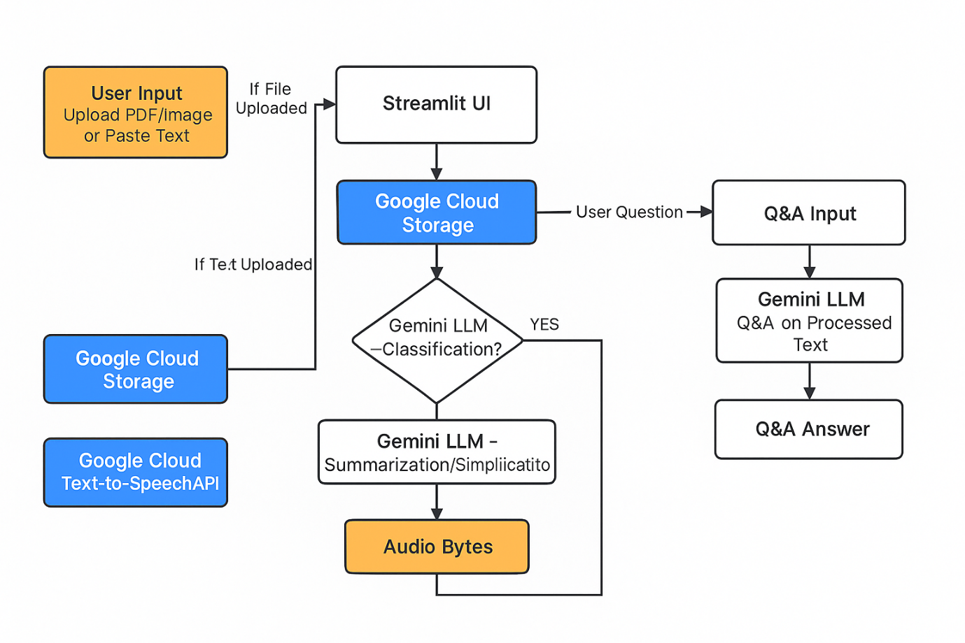

Flow Description:

1. User Input: Users upload a PDF/image or paste text via the Streamlit UI.
2. Cloud Storage: Uploaded files are securely stored in Google Cloud Storage (GCS).
3. OCR: Google Cloud Vision API performs Optical Character Recognition to extract text from files.
4. LLM Processing (Gemini): The extracted text (or pasted text) is sent to the Gemini LLM (via Vertex AI) for:
   * Classification: Determining if the document is financial.
   * Summarization/Simplification: Generating concise insights or plain-language explanations.
   * Q&A: Answering user-specific questions based on the processed text.
5. Text-to-Speech: The processed text output is converted into audio using Google Cloud Text-to-Speech API.
6. Audio Playback: Audio bytes are streamed back to the Streamlit UI for the user to listen.

**4. Technologies Used**

FinAI Mitra is built upon a robust and scalable technology stack, heavily leveraging Google Cloud Platform (GCP) services for its core AI functionalities.

Frontend Technologies

* Python: The primary programming language for the entire application logic.
  + Why: Chosen for its extensive libraries for AI/ML, data processing, and web development, enabling rapid prototyping and efficient development.
  + Role: Orchestrates the entire application flow, handles user input, manages session state, calls GCP APIs, processes responses, and renders the UI.
* Streamlit: For building the interactive and user-friendly web interface.
  + Why: Simplifies the creation of interactive UIs with minimal frontend code, allowing quick development and iteration.
  + Role: Provides all interactive UI elements (uploaders, text areas, dropdowns, buttons) and manages the user session and component rendering.

Backend & AI Services (Google Cloud Platform)

* Google Cloud Storage (GCS): Secure and scalable object storage.
  + Why: Provides highly durable, available, and scalable storage for unstructured data. Essential for AI services that require GCS URIs as input. Offers robust security features.
  + Role: Acts as a temporary staging area for uploaded documents, making them accessible to the Cloud Vision API.
* Google Cloud Vision API: Advanced Optical Character Recognition (OCR).
  + Why: Offers state-of-the-art OCR capabilities, including document_text_detection for PDFs. Eliminates the need for custom OCR model development and maintenance.
  + Role: Extracts all readable text from uploaded PDFs and images, providing the raw text input for LLM processing.
* Google Cloud Vertex AI: Google's unified ML platform.
  + Why: Serves as the central hub for MLOps on Google Cloud, simplifying access, management, and deployment of Google's foundational models.
  + Role: Initializes the SDK and routes all interactions with the Gemini LLM, ensuring secure, managed, and scalable access.
* Gemini (Large Language Model): Specifically, Gemini 2.5 Flash.
  + Why: Chosen for its balance of performance, cost-effectiveness, and speed, suitable for interactive applications. Its strong natural language understanding and reasoning are fundamental.
  + Role: Performs document classification, generates summaries/simplifications, and answers user questions based on document content.
* Google Cloud Text-to-Speech API (TTS): Converts text to natural-sounding audio.
  + Why: Provides high-quality, human-like synthetic voices in multiple languages, enhancing accessibility. Managed service ensures high availability.
  + Role: Synthesizes the processed text (summary, simplification, Q&A answer) into MP3 audio bytes for playback in the UI.

Utilities

* python-dotenv: For secure management of environment variables.
  + Why: Good practice for local development to keep sensitive information out of source control.
  + Role: (Though largely replaced by config.py in this setup for direct import) it represents the principle of externalizing configuration for easy modification and security.

**5. Setup and Installation**

To run FinAI Mitra locally, follow these steps:

Prerequisites

* Python 3.8+
* pip (Python package installer)
* Google Cloud SDK (gcloud CLI) installed and configured
* A Google Cloud Project with Billing Enabled
* Enabled APIs in your GCP Project:
  + Cloud Vision API
  + Vertex AI API
  + Cloud Text-to-Speech API
  + Cloud Storage API
* A Google Cloud Storage (GCS) bucket created in your GCP project.

**6. Usage**

1. Upload Document or Paste Text: Use the file uploader to select a PDF or image, or paste text directly into the text area.
2. Configure Options: Choose the relevant "Country" and "Language for Output" from the dropdowns. Select your desired "Action" (Summarize or Simplify).
3. Process Document: Click the "Process Document" button. The application will show status updates as it uploads, performs OCR, classifies, and processes the document.
4. View Output: The processed summary or simplified text will appear in the output section.
5. Listen to Output: Click "Read Output Aloud" to hear the processed text in the selected language.
6. Ask Questions: Use the "Ask a Question" input to query the document's content or summary.

**7. Responsible AI Practices**

FinAI Mitra is built with Responsible AI principles in mind, recognizing the critical nature of financial data and the potential impact of AI systems. Our approach focuses on several key pillars:

* **Transparency and Explainability:**
  + **Clear Purpose:** The application's core function—extracting, classifying, summarizing, and simplifying financial documents—is explicitly communicated to the user.
  + **Step-by-Step Feedback:** The user interface provides real-time status updates during each stage of processing (upload, OCR, classification, LLM processing), allowing users to understand the system's workflow and identify where issues might occur.
  + **Explicit Classification Outcomes:** If the AI determines a document is *not* financial, this decision is clearly communicated to the user, rather than silently failing or providing irrelevant output.
  + **Prompt-Based Logic:** The AI's behavior for summarization, simplification, and Q&A is driven by carefully engineered prompts. This provides a degree of inherent explainability, as the instructions given to the LLM are part of the application's transparent logic.
* **Fairness and Bias Mitigation:**
  + **Foundational Model Reliance:** We leverage Google's Gemini LLM, a foundational model that undergoes continuous evaluation and refinement by Google for fairness and bias across diverse datasets and use cases. This provides a strong baseline for mitigating inherent biases.
  + **Neutral Prompt Design:** Prompts are crafted to be objective and content-focused, avoiding language or instructions that could inadvertently introduce or amplify biases related to demographics, financial status, or other sensitive attributes.
  + **Content-Centric Processing:** The AI's analysis is strictly based on the content of the provided financial document. This minimizes reliance on external data that could carry historical biases, ensuring that insights are derived directly from the user's input.
* **Privacy and Security:**
  + **Data Minimization:** The application processes only the necessary document content required for its defined tasks. No unnecessary personal or sensitive information is retained beyond the immediate processing cycle.
  + **Secure Storage (GCS):** Uploaded financial documents are stored in private Google Cloud Storage buckets. GCS provides robust security features, including encryption at rest (data is automatically encrypted before being written to disk) and in transit (data is encrypted as it moves between services), as well as fine-grained access controls (IAM policies) to restrict who can access the data.
  + **Google Cloud Security Infrastructure:** All interactions with Google Cloud services (Vision API, Vertex AI, TTS) benefit from Google's world-class security infrastructure, which adheres to stringent industry standards and compliance certifications.
  + **Configuration Management:** Sensitive configurations like GCP project IDs and bucket names are managed via src/config.py (or environment variables in a deployed context), preventing hardcoding of credentials directly in the application code and facilitating secure deployment practices.
* **Reliability and Robustness:**
  + **Production-Grade APIs:** FinAI Mitra relies on Google Cloud's highly available, scalable, and resilient APIs for its core AI functionalities. These services are designed for high uptime and performance.
  + **Comprehensive Error Handling:** The application incorporates try-except blocks throughout its critical functions to gracefully catch and manage potential API failures, network issues, or unexpected responses. User-friendly error messages are displayed in the Streamlit UI, guiding the user on potential next steps (e.g., "Check GCP permissions," "API enabled").
  + **Logging for Diagnostics:** Detailed logging (using Python's logging module) is implemented to capture system behavior, warnings, and errors. These logs are pushed to standard output and can be monitored in Google Cloud Logging, providing crucial diagnostic information for debugging and operational oversight.
* **Accountability and Governance:**
  + **Assistive Tool, Not Decision-Maker:** FinAI Mitra is explicitly designed as an assistive tool to provide insights and summaries, not to make financial decisions. The ultimate responsibility and accountability for any financial actions or interpretations derived from the output remain with the human user.
  + **Clear Disclaimer:** A prominent disclaimer in the UI reminds users that the tool uses AI and should not be used for critical financial decisions without human verification.
  + **Traceability:** The logging infrastructure provides a clear audit trail of document processing events, aiding in debugging, performance monitoring, and compliance.

**8. Hallucination Handling**

Hallucinations are a known challenge with Large Language Models, where they generate plausible but factually incorrect or nonsensical information. In the context of financial documents, hallucinations can have significant negative consequences. FinAI Mitra employs several strategies to mitigate this risk:

* **Strict Prompt Engineering for Grounding:**
  + **Summarization/Simplification:** Prompts are meticulously designed to instruct Gemini to *strictly adhere* to the content provided in the document. For summarization, it's asked to focus on "key financial figures, balances, transactions, and any significant financial details" *from the document*. This guides the LLM to extract and synthesize existing information rather than generating new facts.
  + **Question & Answer (Q&A):** For user queries, the prompt explicitly instructs Gemini: "Based on the following financial summary, answer the question. **If the answer is not in the summary, state that you don't have enough information.**" This crucial instruction prevents the LLM from inventing answers when the required information is not present in the provided context.
* **Contextual Grounding:**
  + By providing the LLM with the *specific, extracted text* from the user's uploaded document (or pasted text) as the primary context for summarization, simplification, and Q&A, we "ground" its responses directly in the source material. This significantly reduces the likelihood of the LLM "hallucinating" information that is not present in the original document.
* **Human Oversight and Verification:**
  + FinAI Mitra is positioned as an **assistant** tool. The output generated by the AI (summaries, simplifications, Q&A answers) is always presented to the user for review.
  + A clear and prominent disclaimer is included in the application's interface, explicitly stating: "This tool uses AI and should not be used for critical financial decisions without human verification." This reinforces the need for human validation, especially for any critical financial decisions.
* **Task-Specific Focus:**
  + The primary tasks performed by the LLM in FinAI Mitra are **extraction, summarization, and simplification** of existing text, and **contextual Q&A**. These tasks are inherently less prone to factual hallucinations compared to purely generative or creative writing tasks, where the LLM is expected to invent new content. By focusing on these specific, well-defined tasks, the risk of hallucination is inherently reduced.

**9. Use Cases**

FinAI Mitra's capabilities can be applied to a wide range of financial use cases:

* Automated Loan Application Processing: Extracting data from loan applications, credit reports, and supporting documents for initial eligibility checks.
* Invoice Automation and Reconciliation: Reading invoices, extracting line items, amounts, and vendor details for automated matching against purchase orders.
* Regulatory Compliance Support: Assisting in scanning regulatory documents, identifying relevant clauses, and aiding in compliance reporting.
* Personalized Financial Advice & Chatbots: Powering intelligent chatbots that can answer customer queries by retrieving information from financial documents like policy terms or account statements.
* Risk Assessment Support: Digitizing financial reports and using AI to extract and interpret key risk indicators from textual data for underwriting.
* Customer Onboarding & KYC: Automating the verification of identity documents and other KYC-related paperwork.
* Financial Research: Quickly summarizing lengthy financial reports, earnings calls transcripts, or market analyses.
* Accessibility Initiatives: Providing audio versions of financial documents for visually impaired individuals or for convenient consumption on the go.

**10. Future Scope**

We are continuously looking to improve FinAI Mitra. Potential future enhancements include:

* More Granular Financial Analysis: Sentiment analysis on reports, trend identification, risk flagging, and specific KPI extraction.
* Multi-Document Processing: Analyze multiple related financial documents simultaneously (e.g., comparing multiple years of financial statements).
* Structured Data Extraction: More robust extraction of data from tables and forms within documents into structured formats (e.g., JSON, CSV).
* User Authentication & History: Allow users to log in, save their processed documents, and review past analyses.
* Interactive Visualizations: Generate charts and graphs based on extracted numerical data.
* Customizable Summaries: Allow users to define summary length or focus areas more precisely.
* Expanded Language Support: Re-introducing support for more languages beyond the current English, Hindi, and German, based on user demand and testing.
* Integration with Financial Systems: Connecting with existing banking or accounting software for seamless data flow.